|  |
| --- |
| KD Games |
| Castle Escape |
| Single Player 2D Platformer Game |
| Version #0.01  All work Copyright © 2016 by KD Games.  All rights reserved. |
| **Deep Pandya (300778345) Khilan Patel (300785048)** |
|  |

|  |
| --- |
| Apr 1st 2016 |

Table of Contents

Update History 3

Game Overview 4

Game Play Mechanics 4

Camera 4

Controls 4

Interface Sketch 4

Menu and Screen Descriptions 5

Game World 5

Levels 5

Enemies 5

Scoring 6

# Update History

Github link: <https://github.com/dpandya76/CastleEscape-FinalGame>

|  |  |  |
| --- | --- | --- |
| Commits | Description | Dates |
| Update 0.01 | Initial Commit | (Apr 1, 2016) |
| Update 0.1 | Created Menu Scene | (Apr 1, 2016) |

## Game Overview

This game will feature a castle where in an innocent person is taken into imprisonment and is given a death sentence. Somehow the person who will be the player, escapes the prison and makes his way to flee the castle. His way to the escape route isn’t easy and he encounters many enemies and hurdles. He will have to find a way to save his life and get freedom.

## Game Play Mechanics

The user has to control the person and the person can walk, jump, move around. There are hurdles in the game and if hit by them the player looses lives. There are scoring options too which allow user to collect item and gain points.

## Camera

The camera is player centric and move along with the player.

## Controls

The player can use WASD to move and also the standard arrow keys.

## Interface Sketch

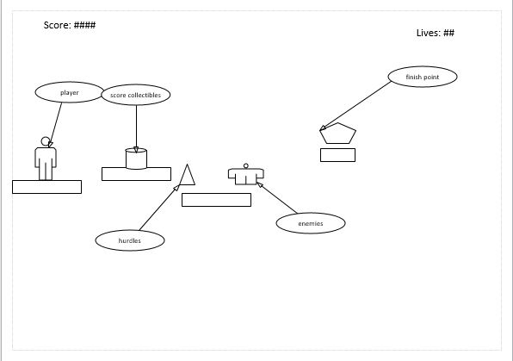

## Menu and Screen Descriptions

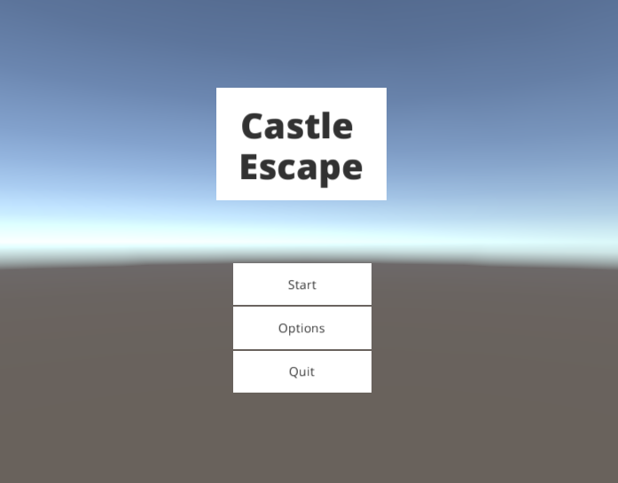

The game menu has options to start the game, quit it and other instructions as to how to move along the game.

## Game World

The game world is a castle of medieval times having dangerous enemies and falling thorns.

## Levels

The game wont be up to three levels where each level will describe a different scene having new challenges for the player to reach to the next level.

## Enemies

The enemies will be varied in sizes and quantities. There will also be hurdles in the way which will decrease the health of player on interaction.

## Scoring

The scoring will be done as player collects treasure chests and reaches to other level.